Disclaimer: Since we were told today that the client wants to change our groups specific questions and did not want the scope of the project to revolve around rentals, we did property instead, and we can alter it and evolve it going forward to see who is getting approved for these multi-family home loans and the factors that go into bank decision making to determine discrimination. Since we were told this today we stuck with our original questions as much as possible and just altered them ever so slightly to be easier for ourselves going forward with where the client wants this project to go.

D1: What is the current distribution of housing listed in current affordable housing programs?

**Sophie Marugg**- In the Total Income-Restricted (affordable housing) there are a total of 56,819 and of these there are 53,962 (95%) affordable rentals and there are a remaining 2,893 (5%) are owned affordable homes/units.

**Brian Li**- Geographic distribution of affordable hosuing (by zip code)- 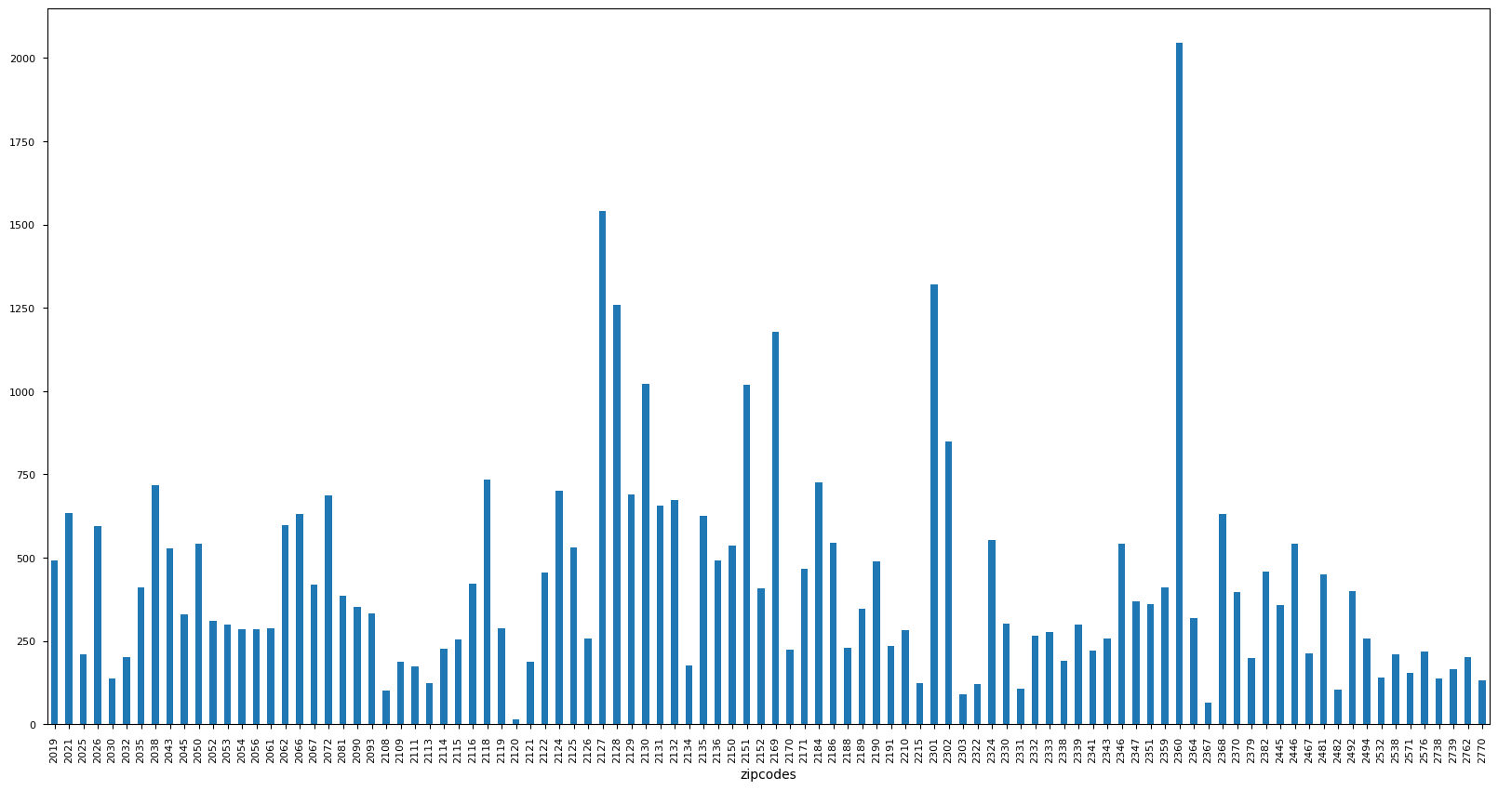

**Brian Li**- By City Counsil District

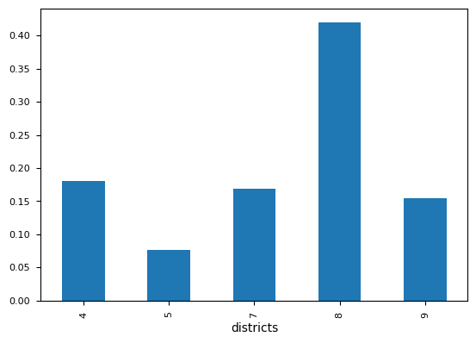

**Adjust question to: What is the current distribution of properties and housing NOT listed in affordable housing programs?**

D1: What is the current distribution of properties NOT currently enrolled in different affordable housing programs?

**Haiwei Sun/Daniel Celaj-**Found from the data set income-restricted -inventory 2021- the total amount for 2021 in this project of units not enrolled in affordable housing was 29,246. This was just data from the one dataset and will be different after finding more sources.

**Sophie Marugg/Daniel Celaj-**Geographic distribution (by zip code)**-**

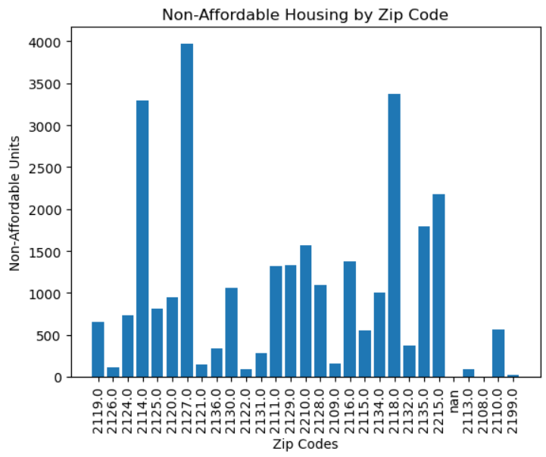

Once we have our map of Boston and create the HeatMap then it should be very clear where the clusters are located. The general presumption will be that once we plot the distribution by zip code there will be a clear trend of demographics in each zip code whether it is income based, gender or racially based. From there we will be able to dive deeper into each cluster and acknowledge whether or not we identify discrimination in bank lending by comparing the demographics of those locations to other locations without affordable housing.